

**COS20001: User-Centered Design**

9.1) Usability Evaluation

**Name:** Dang Vi Luan

**ID:** 103802759

**Evaluation reflection**

We were given a week of preparation for the usability evaluation, during that time, I have been reading the guideline from the online material as well as basic instruction from our lecturer. The evaluation process: however, did not go as well as I expected, there were some flaws in our prototype that we did not expect.

My participant is a college student from a business major, he was extremely friendly and helpful, and after a minute of introduction, I provided him with basic information and context about our team prototype and about what we were about to do. After the briefing of the evaluation, the very first problem arise when our prototype did not work as planned. The log-in and registration page did not allow the user to type in their information, the evaluator then had to use the provided account to continue the assessment.

After a quick tour of our prototype, the participant was asked to complete some tasks, one of which is about changing the theme of the prototype. The participant, at this stage, was quite familiar with our interface and he quickly went to the profile page to change the color of our interface; however, our theme-changing function did not work. After some attempts to fix the problems, we were able to change the theme and for the rest of the evaluation process, everything went smoothly.

During the evaluation process, I have learned some valuable lessons, I have overlooked some procedures listed in the guideline. In addition, despite our team's effort of preparing beforehand, some technical issues still appear and significantly slow down the evaluation.

We were given a lot of constructive feedback and compliments from the participants, they were extremely professional and helpful, even though we had to pause many times during the evaluation. The participant also said that the tasks that we provided them with did not allow freedom for them to further explore the prototype and there was too little time for them to immerse themselves in the potential of our product.

All in all, my evaluation process was quite successful, and I received some valuable feedback to better our team's product. Moreover, this experience had given me a chance to tailor our evaluation method and we will strive to do even better next time.

**Below are some of the moment from the usability evaluation:**

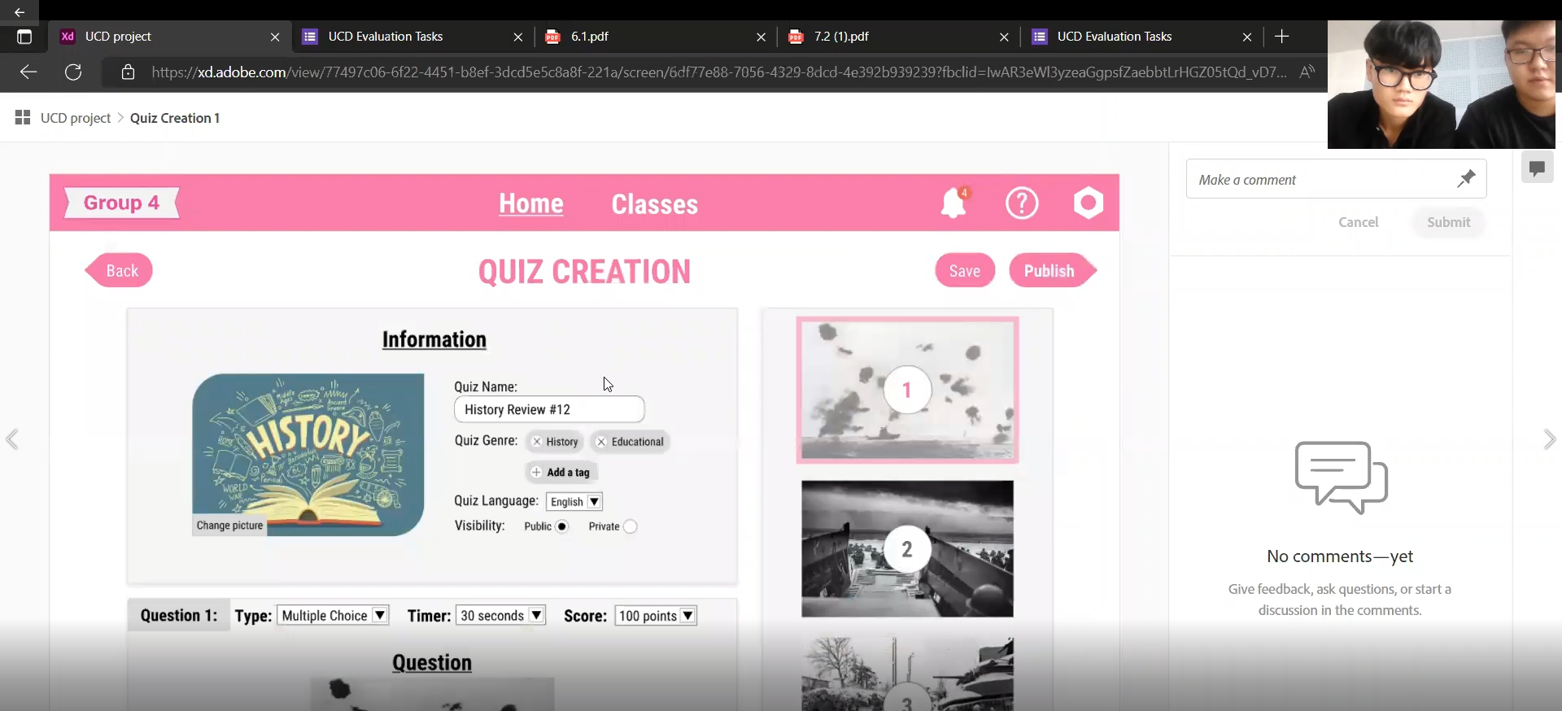

*Picture 1. The participant was asked to create some quizzes*

*Picture 2. The participants successfully create a quiz*

*Picture 3. The participant was asked to delete the account*

*Picture 4. Constructive feedback from the participant*

*Picture 5. The end of the evaluation*